BG Tools – BG Tools – 2D Area Confiner
1) Add the component to an object
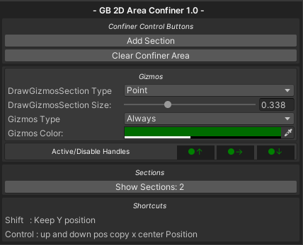

2) Add the first section by tapping the "Add Section" button.
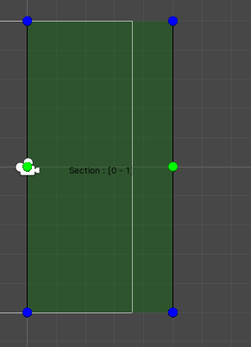
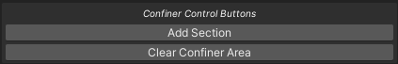
You will be able to visualize in the Scene window the sections, you will also be able to edit them from the points of the vertices that conform the area (blue points at the ends, green points in the centers).

3) You can keep adding sections to the area, as many as you wish, by simply clicking the "Add Section" button again.
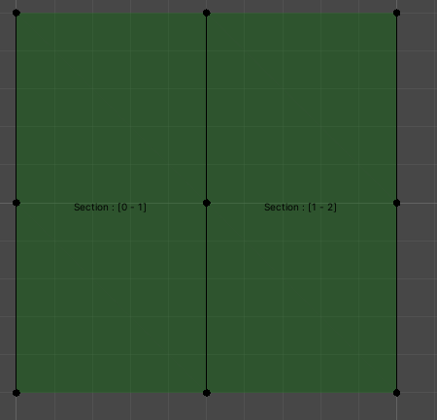

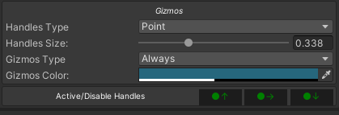
4) Gizmos control and sections manipulation

- Handles type:
      - Circle: free movement
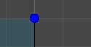

      - Axis: typical transform control
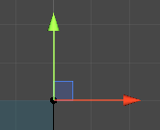

- Handles Size:
If the handles option is set to Point, you can control the size of the control.
- Gizmos Type:
If you select Always even if you do not have the object containing the confiner area component as active, you can display it in the Scene window, otherwise you can only display the area when you have the object selected.

- Color of the display area "Gizmos Color".
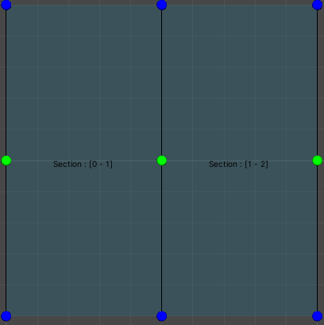
You can change the color of the area.

- Active/Disable Handles: if you wish you can deactivate the handles to edit the positions in the scene.
ALL ACTIVE
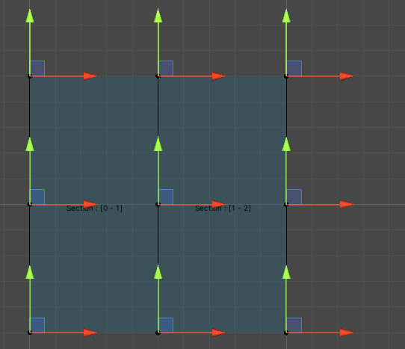

ALL INACTIVE
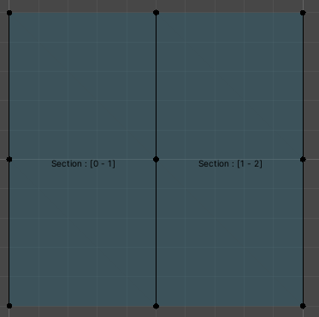

- Manipulate area at the scene:
Simply move the control points to give the desired shape:
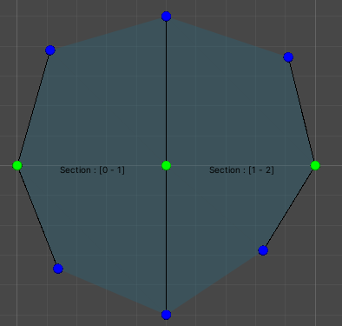

- View the sections and explore the points:
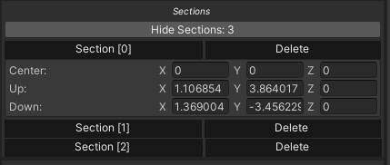
You can expand or collapse each section to see the points that make it up, and you can also delete a section, if you wish.

- Shorcuts
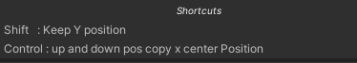

Shift: as long as you move a point the Y position will always remain the same.
Control: the points above and below will move according to the point you move.

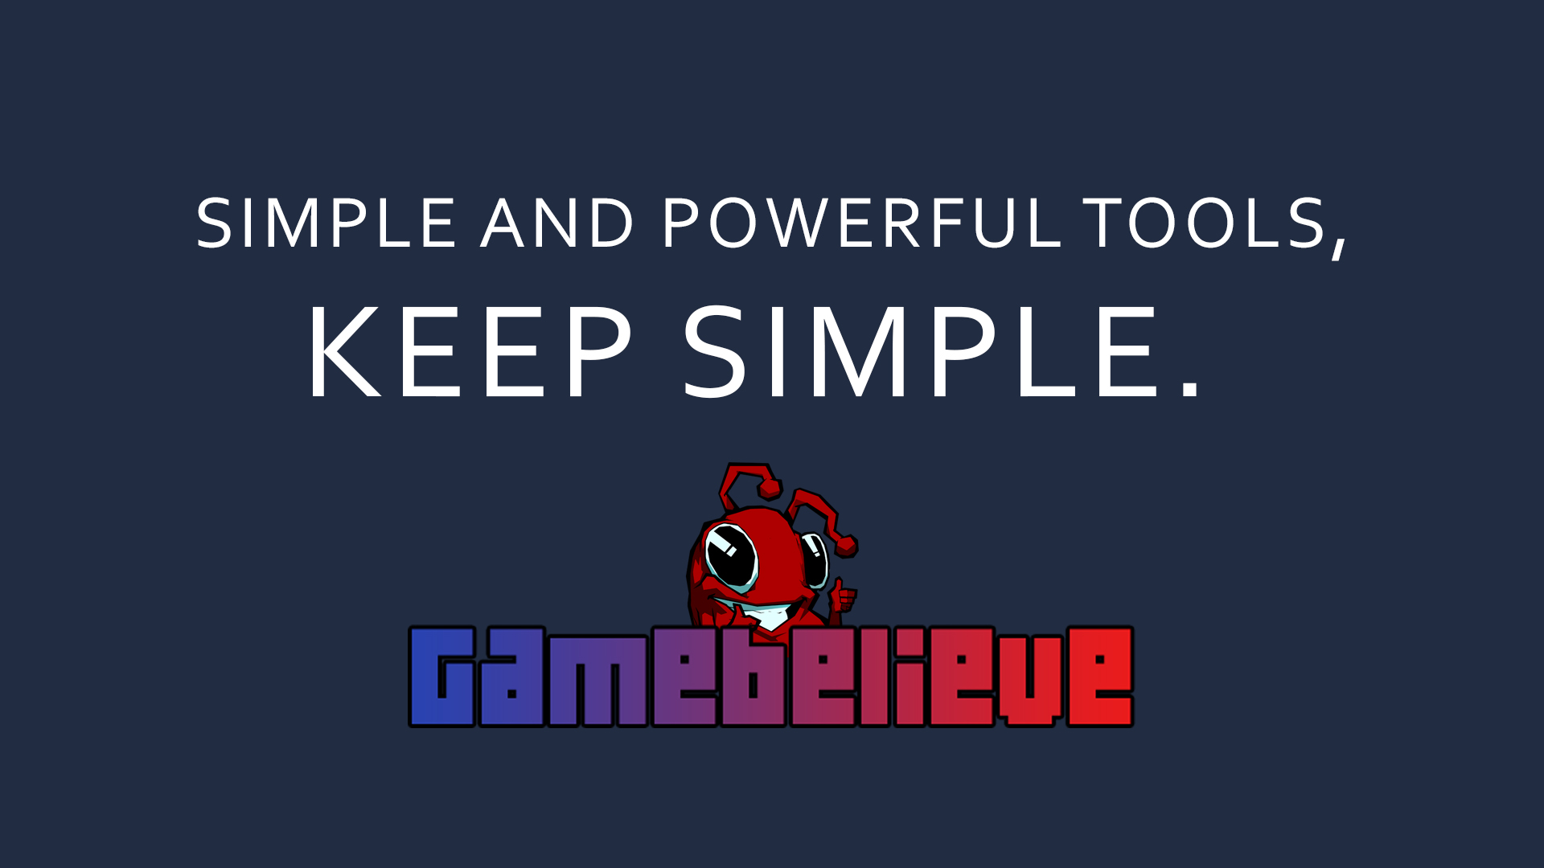

Thank you very much for purchasing the Asset, I hope it can be very useful for you. Many successes!
Your rating is very helpful!

